Bio for Mark Conner

Mark Conner is the Senior Minister of CityLife Church, a diverse community of Christ-followers meeting in multiple locations in Melbourne, Australia. Mark has a genuine love for people and a passion to help them grow and change. He has a Doctor of Ministry degree from Fuller Theological Seminary. Mark is married to Nicole and they have three young adult children.
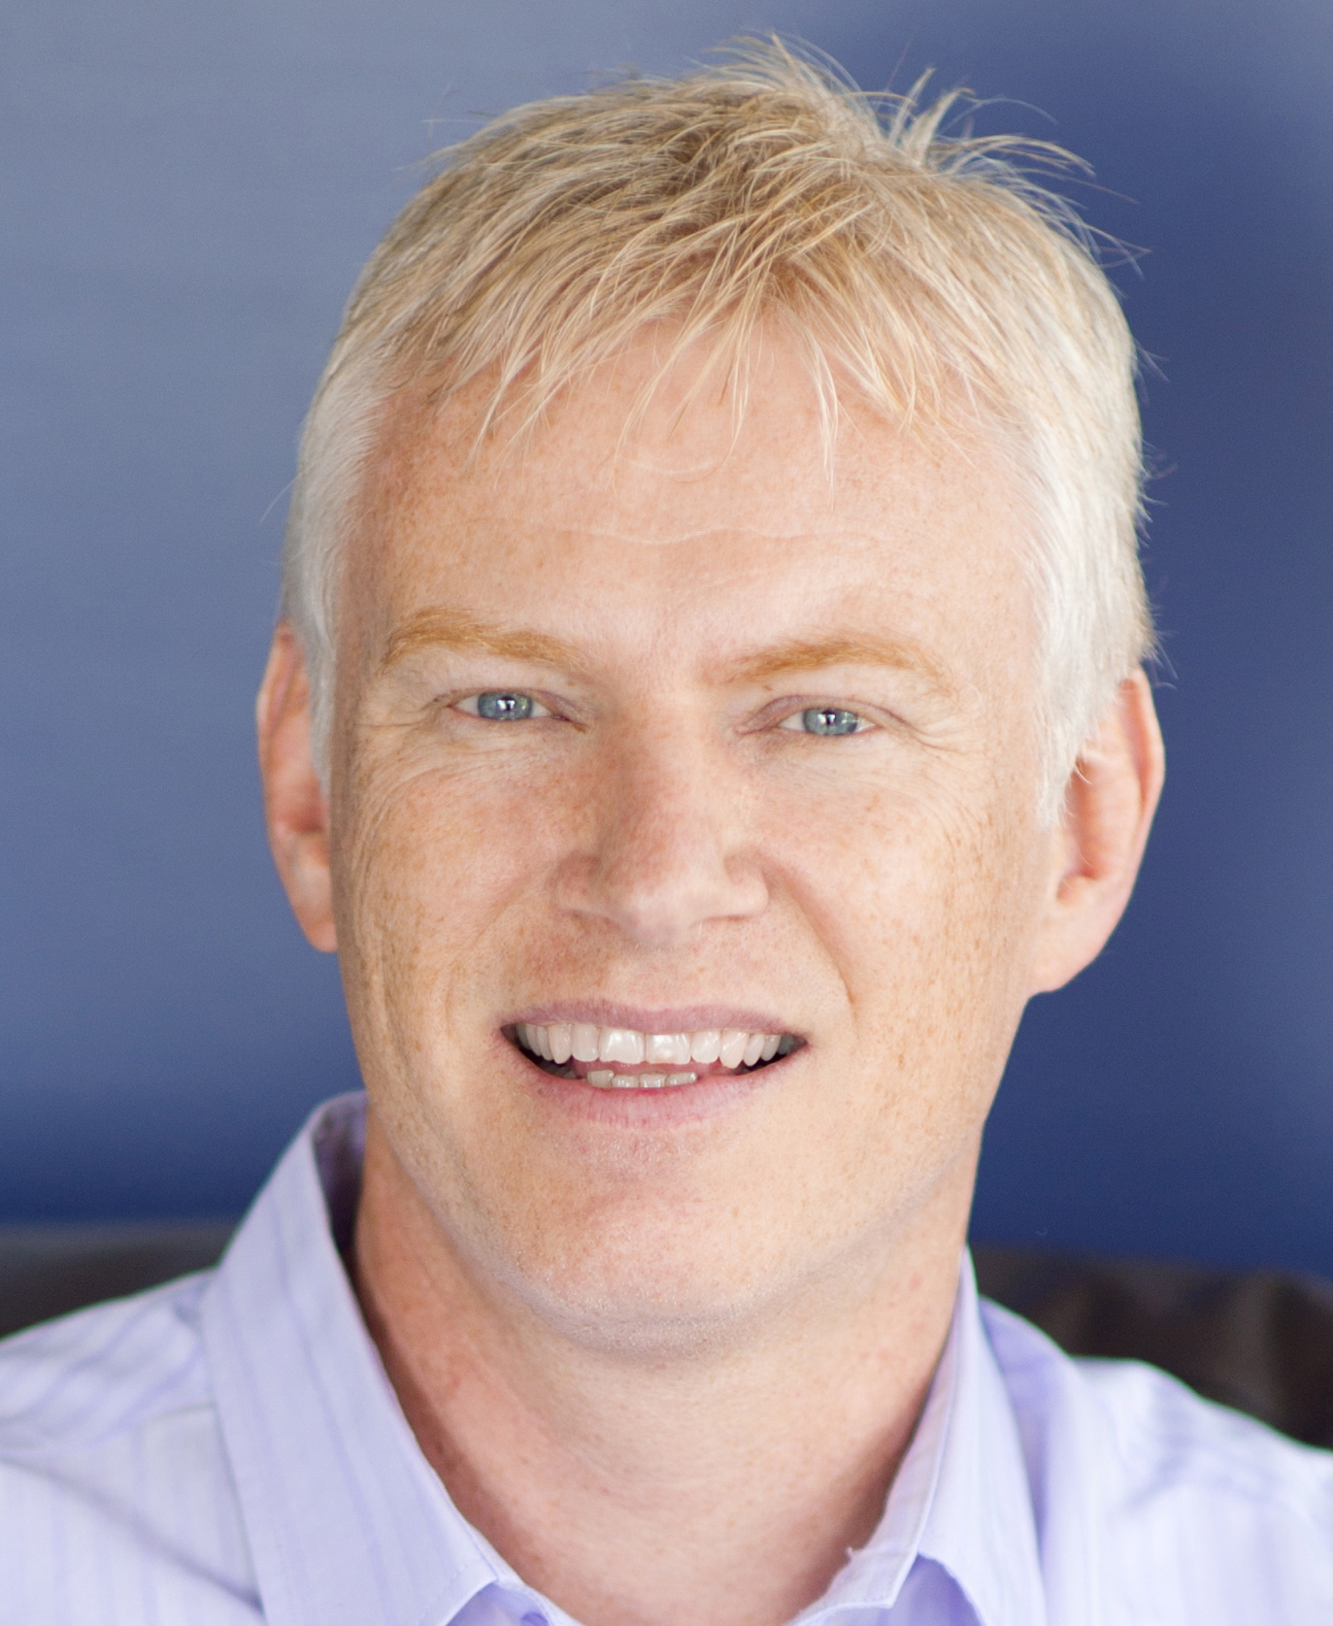
Mark was born in 1961 in Melbourne, Australia. He spent his teenage years in Portland, Oregon where his father, Kevin Conner, was the Dean of Portland Bible College. In 1981, Mark’s family returned to Australia. After five years’ employment at an insurance company, Mark joined the church staff at CityLife Church (formerly Waverley Christian Fellowship) where he has served for thirty-one years in a variety of roles – worship minister, youth pastor, elder (since 1987), business manager, associate pastor and Senior Minister.

CityLife Church was founded in 1967 by Richard Holland who led the church for twenty years. Mark’s father then became the Senior Minister and led it for eight years after which Mark became the Senior Minister, a role has had held since 1995. Under Mark’s leadership the church has grown from a congregation of 1,500 people to over 9,000 people from 105 nationalities who call CityLife their church home. CityLife currently has eleven weekend church services in four locations across the city of Melbourne. It also has an active local community outreach ministry and international mission heart, with active involvement in fifteen nations.

Mark’s interests are sports (basketball and Australian Rules Football), reading books, cooking and music. Mark spent many years as a musician, singer and songwriter. Mark is also an author, having written four books, some of which have been published in other countries and translated into multiple languages.

Mark has been married to Nicole since 1985. Nicole was born in Germany and grew up in South Africa before migrating to Australia where she met Mark. She has been active in church ministry for many years, being involved in leading various ministries as well as in teaching, both locally and overseas. After taking a few years to work in the broader marketplace with a consulting organisation serving humanitarian and not-for-profit ministries, Nicole has a Master’s in History degree and is currently engaging in research work. Mark and Nicole both have a passion to see people grow and change.

Contacts:
Email: mark.conner7@icloud.com
Mobile: +61 411798926
Church Web Site: www.citylifechurch.com
BLOG: www.markconner.com.au
Twitter: @markaconner

